**Blood Bank Management System**



Student Name: Adnan Ali Shah

Registration Number: 2020-KIU-BS2070

Student Name: Wajid Ali

Registration Number: 2020-KIU-BS2064

**Department of Computer Science, KIU, Gilgit**

June, 2024

A Blood Bank Management System

By

Adnan Ali Shah

2020-KIU-BS-2070

Wajid Ali

2020-KIU-BS-2064

A thesis submitted in partial fulfillment of the requirement for the degree of

Computer Science

Department of Computer Science, KIU, Gilgit.

June, 2024

 In the Name of Allah,

The Most Beneficent,

The Most Merciful.

# CERTIFICATE OF APPROVAL

This Project “A Blood Bank Management System” submitted by Adnan Ali Shah (2020-KIU-BS2070) and Wajid Ali (2020-KIU-BS2064) is hereby approved in partial fulfillment of the requirement for the degree of Bachelor of Science in Computer Sciences/Information Technology/Software Engineering” Name of department and University”.

Thesis Supervisor Dr. Gul Sahar

Co-supervisor _______________________

Chairperson/Chairman/HOD Dr. Zarnawab Khan Sawati

External Examiner _________________________

# DEDICATION

I dedicate this project to my respected parents, teachers, friends and family whose support and guidance have been dominant force throughout this amazing journey. Their continuous direction, advice, instruction and supervision has kept me motivated and driven.

A Special Thanks to Dr Gul Sahar for her constant support, help and encouragement throughout the project development.

# DECLARATION

|  |  |
| --- | --- |
| Signature  Scholar Name: Adnan Ali Shah  Reg: 2020-KIU-BS2070  Date: _____________________ | Signature  Supervisor Name: Dr. Gul Sahar  Date: ______________________________ |
| Signature  Scholar Name: Wajid Ali  Reg: 2020-KIU-BS2064  Date: _____________________ | Signature  Supervisor Name: Dr. Gul Sahar  Date: ______________________________ |

I hereby declare that this thesis/project is a presentation of our own work and that it has not been submitted anywhere for any award. We also warrant, that we have not received outside assistance or involved the external contributions, if received/involved we will acknowledge in written statement to authorities, otherwise we will be liable for the cancellation of our thesis thereby the degree that will be awarded.

# ACKNOWLEDGEMENTS

**“To him belongs the dominion of the Heaven and the Earth, it is He who gives life and death and He has power over all things” (AL-QURAN)**

All praise to Almighty Allah who gave us the understanding, courage and patience to complete this project.

I express my gratitude to project supervisor **Dr. Gul Sahar** who provided me the opportunity to learn and enhance knowledge. As the project supervisor, she had been ready to help and guide me throughout the project development. I would also like to thank our teachers in the department and friends for their moral and technical support.

I would like to acknowledge the support of my family members, I would like to admit that I owe all my achievements to my truly, sincere and loving parents whose prayers are a source of determination for me.

Last but not least, I would like to extend my gratitude to everyone who has been helping me directly or indirectly from the beginning until the final stage of this project. All the helps and cooperation from various parties are truly appreciated.

# ABSTRACT

The availability of safe and adequate blood supplies is critical in healthcare, especially during emergencies, where delays can be life-threatening. Traditional methods of managing blood donations, inventory, and transfusions often suffer from inefficiencies, manual errors, and delays, leading to challenges in timely patient care. To address these issues, this project introduces a Web-Based Blood Bank Management System designed to streamline blood bank operations through an online platform. The system provides real-time access to critical information, such as blood inventory, donor records, and transfusion requests, accessible from any internet-enabled device.

Key objectives include automating manual processes to reduce human errors, improving data accuracy, and enabling healthcare providers to respond swiftly to blood demands. The system ensures the efficient tracking of blood availability, enhances collaboration between hospitals and blood banks, and supports compliance with regulatory standards. By facilitating seamless communication and data exchange, the system aims to improve the overall quality of patient care and optimize the management of blood resources in healthcare facilities.

Blood Bank Management System(BS 2020-2024

# TABLE OF CONTENTS

Chapter Page

CERTIFICATE OF APPROVAL iv

DEDICATION v

DECLARATION vi

ACKNOWLEDGEMENTS vii

ABSTRACT viii

TABLE OF CONTENTS x

LIST OF FIGURES xiv

ACRONYMS AND ABBRIVIATION xv

Chapter 1 1

INTRODUCTION 1

1.1. Background 1

1.2. Project Overview 1

1.3. Project Motivation 2

1.4. Study rationale and relevance 2

1.5. Aims and objectives 3

*1.5.1* *Goals* 3

1.6. Problem Statement 3

1.7. Advantages of proposed System 4

1.8. Main Modules of Project 5

Chapter 2 6

REVIEW OF LITERATURE 6

2.1. Overview 6

2.2. Existing Clinical Management System 6

2.3. Need for an Integrated System 7

2.4. Limitations 7

Chapter 3 9

REQUIREMENT SPECIFICATION 9

3.1. Functional requirements 9

*3.1.1.* *Functions* 9

3.2. Nonfunctional requirement 10

*3.2.1.* *Security* 10

*3.2.2.* *Performance* 10

*3.2.3.* *Usability* 10

*3.2.4.* *Scalability* 10

3.3. Required tools and technologies 11

Chapter 4 12

DESIGN 12

4.1. System architecture 12

4.2. Design Constraints 13

4.3. Design methodology 14

4.4. Process flow 15

4.5. Use case Models 15

4.6. Data Flow Diagram 20

4.7. Database Design 22

*4.7.1.* *Design Database:* 22

4.8. GUI Design 23

*4.8.1.* *Home Screen***:** 23

*4.8.2.* *Login Screen***:** 23

*4.8.3.* *Donate Screen:* 24

*4.8.4.* *Request Screen:* 24

*4.8.5.* *SignUp Screen:* 25

Chapter 5 26

System Implementation 26

5.1. Implementation 26

5.2. Tools and Technologies 26

5.3. Frontend 27

5.4. Backend 27

5.5. Database 27

5.6. Testing and Quality Assurance 28

5.7. Deployment and User Training 28

5.8. Maintenance and Updates 28

Chapter 6 29

SYSTEM TESTING AND EVALUTION 29

Unit testing 29

**Unit Testing 1:** 29

**Unit Testing 3:** 31

Chapter 7 32

CONCLUSION 32

FUTURE WORK 33

References 35

APPENDICES 36

Appendix A 36

Appendix B 37

Main frontend code: 37

Main Backend Code: 38

# LIST OF FIGURES

Figures Pages

**Figure 1 Agile Design Methodology** 14

**Figure 2: Flowchart Diagram** 15

**Figure 3: Blood Bank Figure** 16

**Figure 4: Use Case for Donor** 17

**Figure 5: Use Case for Admin** 18

**Figure 6: Blood Bank Staff** 19

**Figure 7: Level 0 DFD** 20

**Figure 8: Level 1 DFD** 21

**Figure 9: ERD Diagram** 23

**Figure 10: Home Screen** 24

**Figure 11: LogIn Screen** 24

**Figure 12: Donate Screen** 25

**Figure 13: Request Screen** 25

**Figure 14: SignUp Screen** 26

# ACRONYMS AND ABBRIVIATION

|  |  |  |
| --- | --- | --- |
| CS |  | COMPUTER SCIENCES |
| KIU |  | KARAKORAM INTERNATIONAL UNIVERSITY |
| IT |  | INFORMATION TECHNOLOGY |
| SE |  | SOFTWARE ENGINEERING |
| APP |  | APPLICATION |
| ICT |  | INFORMATION AND COMMUNICTION TECHNOLOGY |
| DFD |  | DATA FLOW DIAGRAM |
| ERD |  | ENTIT RELATIONAL DIAGRAM |
| GUI |  | GRAPHICAL USER INTERFACE |
| RDBMS |  | RELATIONAL DATABASE MANAGEMENT SYSTEM |
| UI |  | USER INTERFACE |

# Chapter 1

## INTRODUCTION

## Background

Safe and adequate blood supplies are crucial for healthcare, especially in emergencies where delays can be life-threatening. Traditional methods of managing blood donations, inventory, and transfusions often rely on manual processes, leading to inefficiencies, errors, and delays. These challenges compromise timely patient care, coordination between blood banks and hospitals, and efficient blood resource management.

A Web-Based Blood Bank Management System (WB-BBMS) addresses these issues by providing an online platform that automates key functions such as blood inventory tracking, donor management, and transfusion requests. The system offers real-time access to critical data from any internet-enabled device, allowing healthcare providers to quickly respond to blood demands. Additionally, it enhances collaboration between hospitals and blood banks, reduces manual errors, and supports regulatory compliance. By streamlining operations and facilitating better communication, the WB-BBMS improves the overall efficiency and safety of blood management, ultimately enhancing patient care outcomes.

## Project Overview

The Web-Based Blood Bank Management System (WB-BBMS) aims to streamline the management of blood donations, inventory, and transfusions by replacing inefficient manual processes with a secure, automated online platform. The system provides real-time access to blood inventory, donor data, and transfusion requests, ensuring healthcare providers can respond swiftly to blood demands.

Key features include automated donor management, real-time stock updates, and secure transfusion processing, improving data accuracy and operational efficiency. By facilitating seamless communication between blood banks and hospitals, the WB-BBMS reduces manual errors, optimizes blood resource use, and enhances patient care, particularly during emergencies.

## Project Motivation

The motivation for this project stems from the critical need to ensure timely access to safe blood supplies in healthcare, especially during emergencies. Traditional manual methods of managing blood donations, inventory, and transfusion requests are prone to errors, inefficiencies, and delays, which can jeopardize patient outcomes. A Web-Based Blood Bank Management System offers a modern solution to these challenges by automating processes, improving data accuracy, and providing real-time access to vital information. This system is designed to enhance the coordination between blood banks and healthcare providers, ensuring a more efficient, responsive, and reliable blood supply management system that ultimately improves patient care.

## Study rationale and relevance

The inefficiencies of conventional, manual blood bank management techniques, which frequently cause delays, mistakes, and inadequate coordination in the healthcare industry, are the focus of this research. For rapid and reliable blood supply management, particularly during emergencies, a Web-Based Blood Bank Management System (WB-BBMS) is needed. The system provides real-time access to donor information, transfusion requests, and blood inventory, automates critical operations, lowers errors, and guarantees regulatory compliance. These features improve communication between blood banks and hospitals.

Because it increases operational effectiveness, maximizes blood resources, and ultimately improves patient care, the WB-BBMS is important in today's healthcare environment.

## Aims and objectives

This project's main goal is to create a Blood Bank Management System that are reliable, easy to use, and secure.

### *Goals*

1. Automate manual processes to reduce errors in blood donation, inventory tracking, and transfusion management.
2. Enhance communication and coordination between blood banks, hospitals, and healthcare providers.
3. Optimize blood resource management by ensuring efficient allocation of blood supplies and reducing wastage.
4. Ensure regulatory compliance by securely managing sensitive donor and patient data in accordance with healthcare standards.
5. Improve overall patient care by enabling faster, more accurate response to blood needs, particularly in emergencies.

## Problem Statement

The management of blood supplies in healthcare is critical for ensuring timely and safe transfusions, especially in emergency situations. However, traditional methods of managing blood donations, inventory, and transfusion requests are often reliant on manual processes, leading to significant inefficiencies, delays, and errors. These shortcomings can result in inadequate blood availability, miscommunication between blood banks and healthcare providers, and increased risk for patients requiring urgent care. As a result, healthcare facilities struggle to maintain accurate blood inventory records, track donor eligibility, and respond swiftly to transfusion demands.

This project seeks to address these challenges by developing a Web-Based Blood Bank Management System (WB-BBMS) that automates and streamlines blood bank operations. By providing real-time access to critical data and enhancing communication across healthcare settings, the WB-BBMS aims to improve the efficiency, reliability, and safety of blood management, ultimately enhancing patient outcomes in critical care scenarios.

## Advantages of proposed System

There are various benefits associated with the suggested Blood Bank Management System that incorporates Blood Bank functionality:

* + 1. **Automation of processes**: Reduces manual intervention in blood management tasks, minimizing the risk of human errors and increasing overall efficiency.
    2. **Real-time Updates**: Provides healthcare providers with immediate access to blood inventory, donor information, and transfusion requests, facilitating timely decision-making.
    3. **Improved patient-care:** Streamlines blood supply management processes, enabling faster response times during emergencies and ultimately leading to better patient outcomes.
    4. **Data security**: The system will put all the security measure to secure the patient’s all the sensitive data and all the information are safe and secure.
    5. **Cost Effective**: By optimizing blood resource management and reducing wastage, the system can lead to cost savings for healthcare facilities.
    6. **User Friendly Interface**: Provides an intuitive interface that simplifies training and encourages adoption by healthcare staff, improving overall operational efficiency.

## Main Modules of Project

The system will consist of several key modules that work together to enhance the efficiency of clinical and emergency care:

* User Management module
* Donor Management Module
* Blood Inventory Management Module
* Emergency Response Module
* Security and Compliance Module

Each of the module has significant role in ensuring the system’s functionality and efficiency, collectively contributing to save the time and easily cure the disease of patient and helps health professionals to easily make decisions.

# Chapter 2

## REVIEW OF LITERATURE

## Overview

Blood banks play a vital role in healthcare, ensuring the availability of safe and timely blood supplies for patients in need, particularly in emergency situations. Traditional blood bank management methods, which often rely on manual processes, face significant challenges in maintaining accuracy and efficiency. Research has shown that these methods are prone to delays, human errors, and miscommunication between blood banks and healthcare facilities, potentially endangering patient outcomes. The review of literature explores existing systems, the need for an integrated solution, and the limitations of current approaches, emphasizing the importance of adopting web-based automated systems to optimize blood bank operations.

## Existing Clinical Management System

Most blood banks and healthcare facilities continue to use manual or semi-automated systems to manage blood donations, inventory, and transfusions. These systems often involve paper records or fragmented databases that require frequent manual updates. Studies by Singh and Kaur (2018) have pointed out that traditional methods are inefficient in tracking blood availability, leading to delays in fulfilling transfusion requests. Similarly, Rao et al. (2019) highlight the challenges of ensuring real-time updates, as blood stock levels often change rapidly, making it difficult for healthcare providers to access accurate data when needed.

Although some institutions have adopted standalone software for blood bank management, these systems are often not integrated with hospital management systems, resulting in data silos and poor coordination. Patel and Sharma (2020) note that the lack of real-time data exchange between blood banks and hospitals causes delays in transfusion requests and increases the risk of blood shortages or wastage.

## Need for an Integrated System

The need for a fully integrated, web-based blood bank management system (WB-BBMS) is becoming increasingly apparent. Ahmed et al. (2021) argue that integrating blood bank operations with hospital systems enables real-time tracking of blood inventory and donor information, leading to better coordination between blood banks and healthcare providers. An integrated system eliminates the need for manual data entry, ensuring that inventory updates are automatic and immediately available to all stakeholders. This reduces the risk of human errors and ensures a quick response to critical blood demands.

Moreover, Malik and Siddiqui (2022) emphasize the importance of seamless communication between hospitals and blood banks to improve the allocation and distribution of blood supplies. A centralized, web-based platform ensures that healthcare facilities, regardless of location, can access accurate, up-to-date information on blood availability and transfusion requests. This level of integration enhances the overall efficiency of the system and helps ensure patient safety.

## Limitations

Despite the availability of some automated blood bank systems, existing solutions often suffer from significant limitations. Many current systems are not web-based, which restricts accessibility to local networks, limiting their usability for remote or multi-site operations. As Singh and Kumar (2020) point out, a lack of real-time access to blood inventory data can delay critical decisions during emergencies, where timely responses are essential.

Additionally, many existing systems do not adequately address the issue of data security, which is particularly important in healthcare due to the sensitivity of patient and donor information. Malik and Siddiqui (2022) note that older systems lack encryption and compliance features, increasing the risk of data breaches. Other limitations include poor scalability, with systems designed for smaller operations struggling to meet the needs of larger hospital networks, as well as inadequate support for regulatory compliance, which is critical for ensuring that blood management processes meet health and safety standards.

Overall, the literature highlights the limitations of traditional and semi-automated blood bank systems, underscoring the need for a more advanced, integrated solution. A web-based platform offers real-time access, improved coordination, better data security, and scalability, making it the ideal solution for addressing current inefficiencies and improving patient care.

# Chapter 3

## REQUIREMENT SPECIFICATION

## Functional requirements

The functional requirements of the system are categorized into several key modules and submodules, each serving specific purposes:

### *Functions*

The main functions of “**Blood Bank Management System**” are as following:

**User Management**

* The system must allow for user registration and login with role-based access control (e.g., administrators, blood bank staff, healthcare providers).

**Donor Management**

* The system must track donor information, including personal details, eligibility status, and donation history.

**Communication Module**

* The system should enable communication between blood banks and hospitals, facilitating the quick fulfillment of blood requests.

**Blood Inventory Management**

* It should track incoming donations and outgoing transfusions to keep inventory up to date.

## Nonfunctional requirement

### *Security*

* The system must ensure data encryption for all sensitive information, including donor and patient data.
* Role-based access control must be implemented to restrict access to sensitive features based on user roles.
* Maintain strict data access controls and logging mechanisms to detect unauthorized access.

### *Performance*

* The system must process data efficiently, handling up to much more users without any performance degradation.
* All the critical and imported actions should be completed within time.

### *Usability*

* The user interface must be interactive and user-friendly, requiring minimal training for healthcare staff.
* The interface should be intuitive, allowing users to easily navigate features such as blood inventory tracking, donor management, and reporting.

### *Scalability*

* The system must be scalable to accommodate multiple blood banks and hospitals, ensuring that it can handle growing amounts of data and users over time.

## Required tools and technologies

The required tools and technologies to run this web app are as under.

OS: Any OS (Web app doesn’t depend on OS)

Internet for Smooth user experience a high-speed internet

Code Editor: Any code editor (VS Code etc.)

Frontend: ReactJS

Backend: Node.js, Express.js

Database: XAMPP for MySQL

# Chapter 4

## DESIGN

## System architecture

The system architecture of the Web-Based Blood Bank Management System (WB-BBMS) is designed to ensure efficient, secure, and scalable management of blood bank operations. The architecture follows a multi-tier structure, comprising a presentation layer, an application layer, and a database layer. The **presentation layer** is the user interface that healthcare professionals, blood bank staff, and donors interact with through web browsers or mobile applications. It provides access to features like donor registration, blood inventory tracking, and transfusion request management, ensuring an intuitive and user-friendly experience.

The application layer serves as the core of the system, hosting business logic and handling data processing. This layer is responsible for executing functionalities such as managing user roles, processing blood donation data, checking donor eligibility, updating blood inventory, and generating reports. It communicates with both the presentation and database layers to fetch, process, and display real-time information. The application layer also ensures secure communication between different system components, incorporating encryption and role-based access control to protect sensitive data.

The database layer is the backbone of the system, where all data related to donors, blood inventory, transfusion requests, and transaction history is stored. This layer is designed using a relational database that ensures data integrity, allowing for real-time updates and fast querying. Backup and disaster recovery mechanisms are implemented to ensure data availability and reliability. The system architecture also supports integration with external hospital systems through APIs, enabling smooth data exchange and improving operational efficiency. This modular and layered approach ensures that the WB-BBMS can scale as needed, while maintaining high performance, security, and usability.

## Design Constraints

Several constraints have been considered in the design of the system:

* The system must be compatible with major web browsers (e.g., Chrome, Firefox, Safari) and mobile devices to ensure widespread accessibility, but this may limit the use of certain advanced technologies that aren't supported uniformly across all browsers.
* Ensuring that the system functions smoothly across different devices (desktop, tablets, smartphones) introduces design constraints related to responsive design and interface consistency.
* The system should be user-friendly for healthcare professionals and user, minimizing the need of extensive trainings.
* Security constraints to adhere to industry standards and best practices for protecting user data and financial transactions.

## Design methodology

An agile methodology is employed for the design and development of the system. This approach emphasizes iterative and incremental development, allowing for continuous feedback and adaptation. Regular sprint cycles involve requirements gathering, design, implementation, testing, and deployment phases. This iterative process ensures that the system evolves based on stakeholder feedback and changing

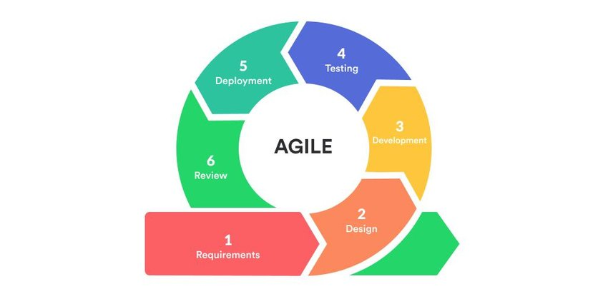needs.

**Figure 1 Agile Design Methodology**

## Process flow

The following are the major process flow of our system which are shown in the figure below:

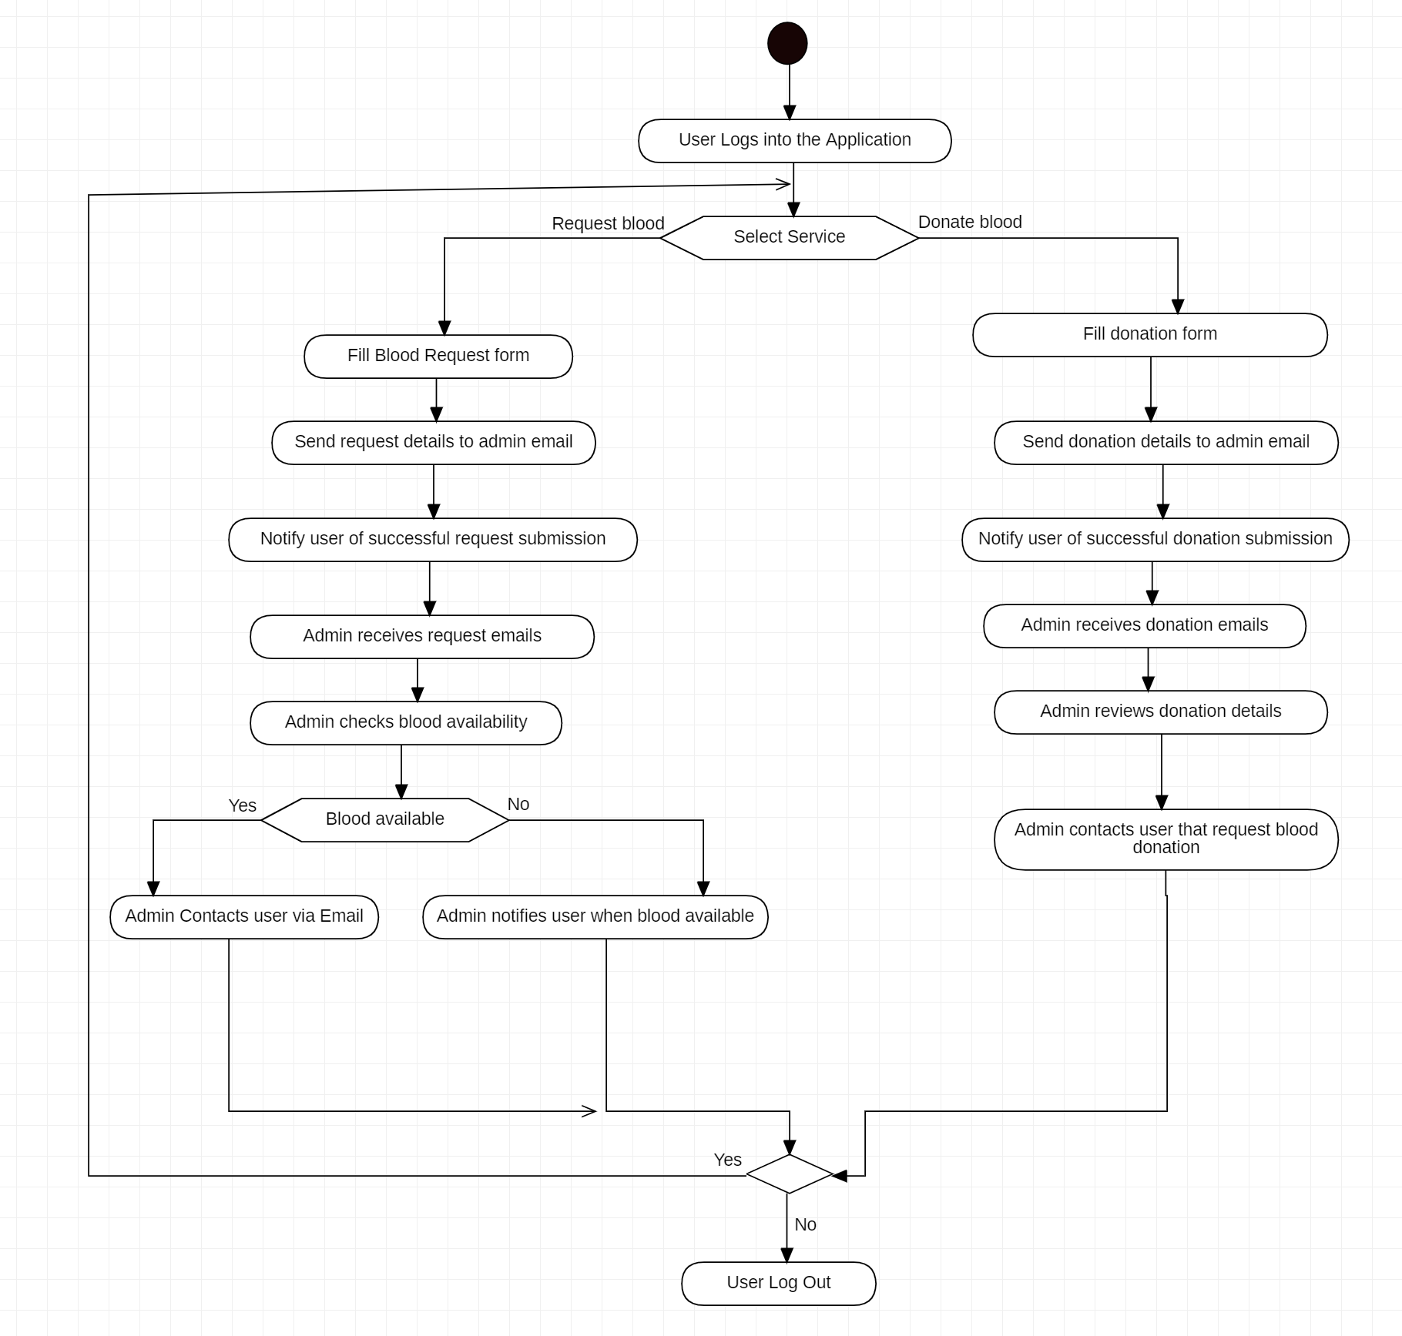

**Figure 2 Flow Chart Diagram**

## Use case Models

A use case model is a visual representation of the functional requirements of a system from the perspective of its users. It helps to describe the interactions between users and the system, capturing the various ways users can interact with the system to achieve specific goals. In the proposed Blood Bank Management System, the main use cases are:

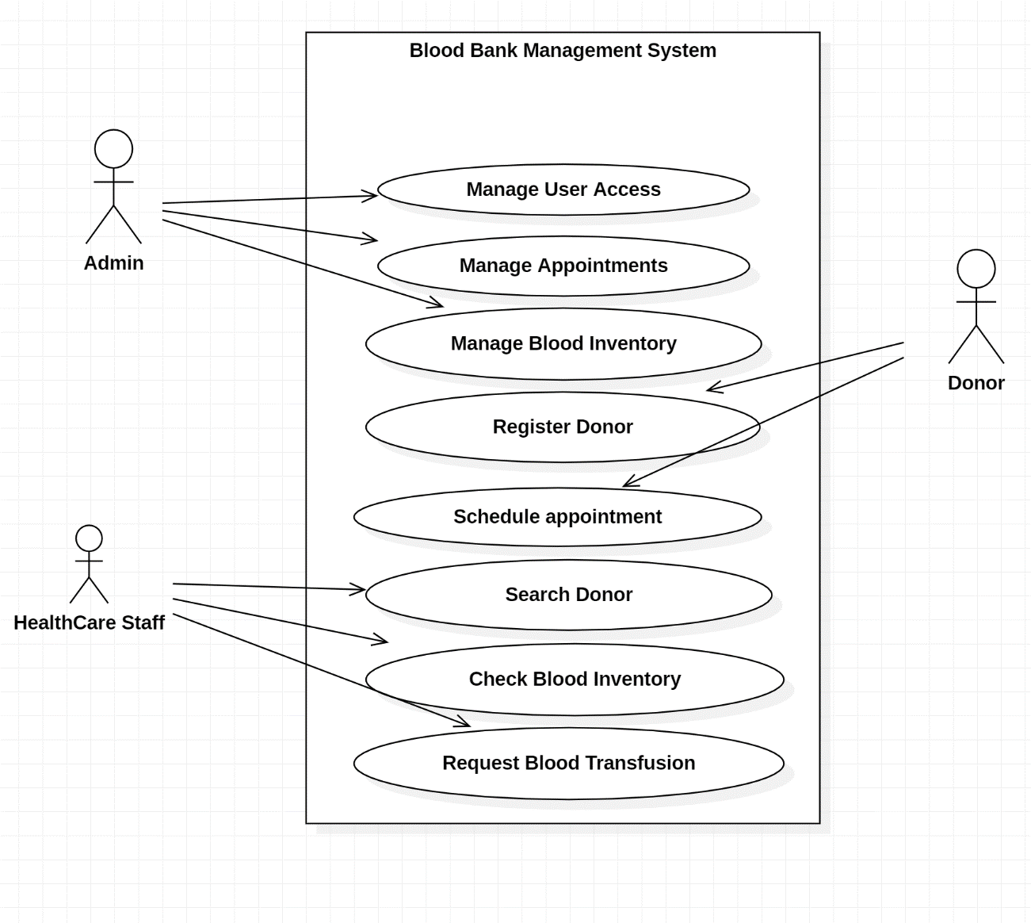

**Figure 3: Blood Bank Figure**

**Actors:**

**Donor:** The donor is an individual who donates blood and interacts with the system to manage their donation history and eligibility.

1. Register and manage personal information.
2. Schedule donation appointments.
3. Receive notifications about upcoming donation opportunities.

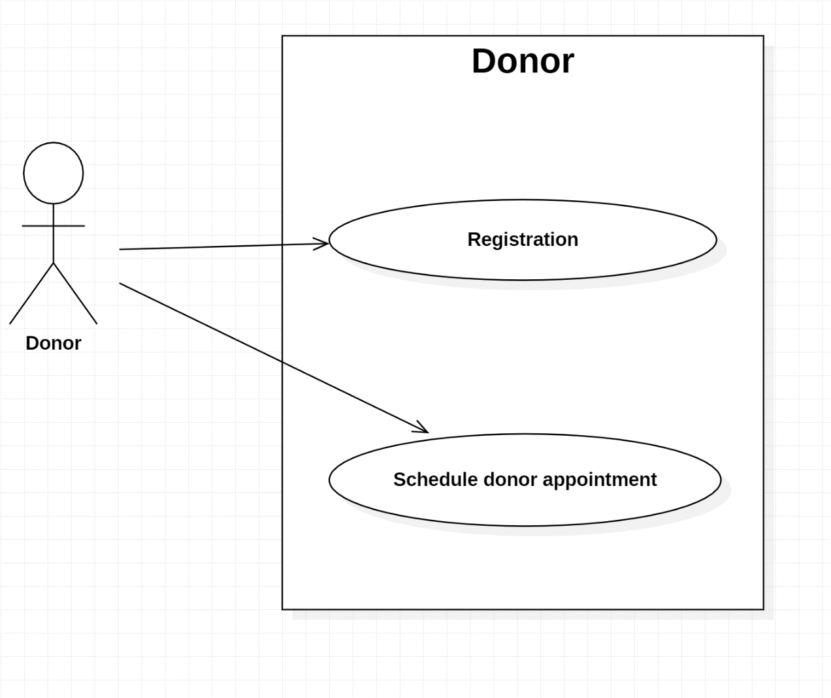

**Figure 4: Use Case for Donor**

**Admin Staff (User Access, Appointment, Blood Inventory):** Users responsible for approving document applications.

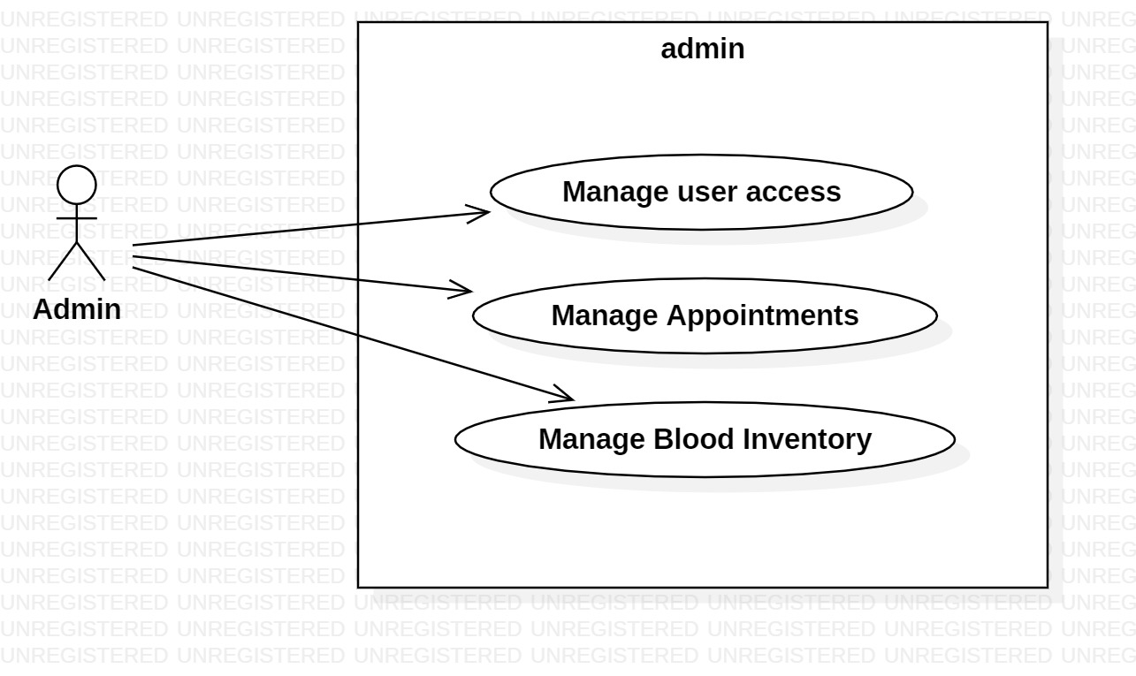

**Figure 5: Use Case for Admin**

**Actions in Blood Bank Staff Use Case:**

1. **Request Donor:** All the users must log into the system by providing their correct or valid username and password. It is the initial step to access the system's features.
2. **Search Donor:** After logging in, the user can view the dashboard, which serves as the main interface for various activities.
3. **Check Blood Inventory:** The users also request for the blood inventory on the dashboard and save their time and resources and handle emergency situations easily.
4. 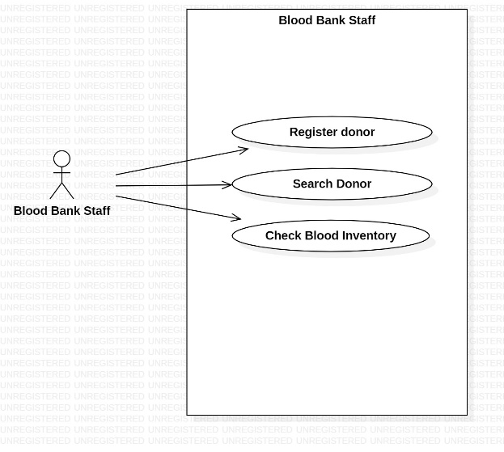**Logout:** Users can securely log out of their accounts, ending their session completely.

**Figure 6: Blood Bank Staff**

## Data Flow Diagram

A data flow diagram (DFD) provides a visual representation of how data flows through Blood Bank Management System need between its various components. Here are the main key components in DFD:

**Context-Level DFD (Level 0 DFD):**

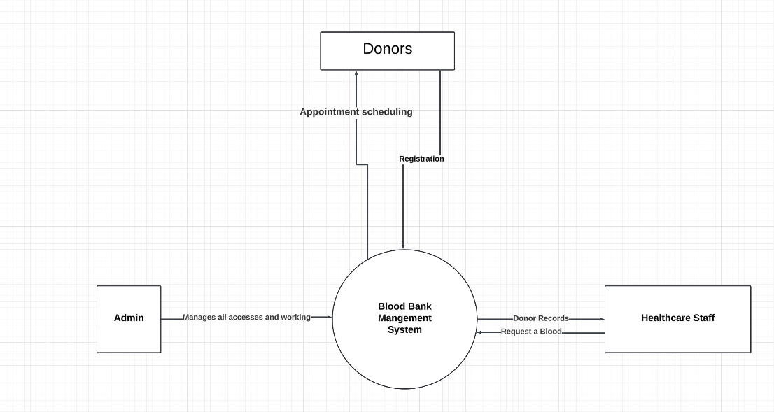In the context-level DFD, we'll represent this system as a single process, showing the external entities, data flows, and processes that interact with it.

**Figure 7: Level 0 DFD**

Figure : Level 0 DFD

**Level 1 DFD:**

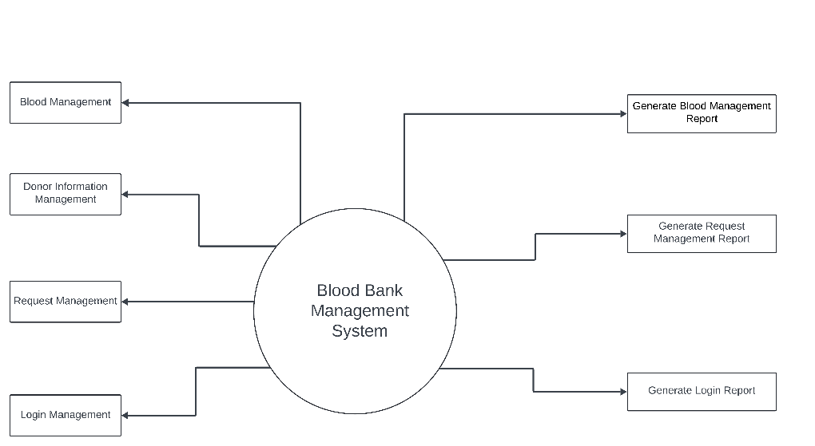This Level 1 DFD breaks down the "Blood Bank Management System" process into its sub-processes and shows the data flows between them, as well as the data stores and external entities involved.

**Figure 9: Level 1 DFD**

## Database Design

It is important to store and manage records in every software or application. Here all fee records are stored in the database, so whenever a specific record is required, it can be extracted easily. The database acts as a warehouse for storing data in the project.

### *Design Database:*

The database design is structured as follows:

* User Table: Stores the user credentials for login and authentication.

## GUI Design

The graphical user interface (GUI) design focuses on simplicity, usability, and a consistent user experience. Wireframes and mockups have been created for key screens:

### *Home Screen***:**

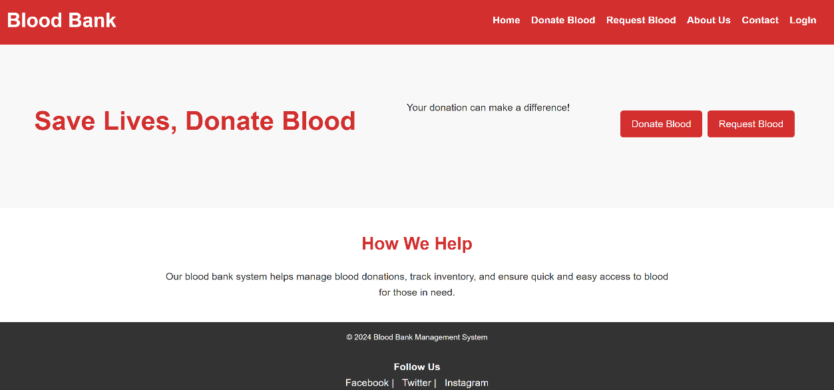Displays the name, logo, and Registration options.

**Figure 10: Home Screen**

### *Login Screen***:**

Displays the login credentials (username and password) and a Sign in button.

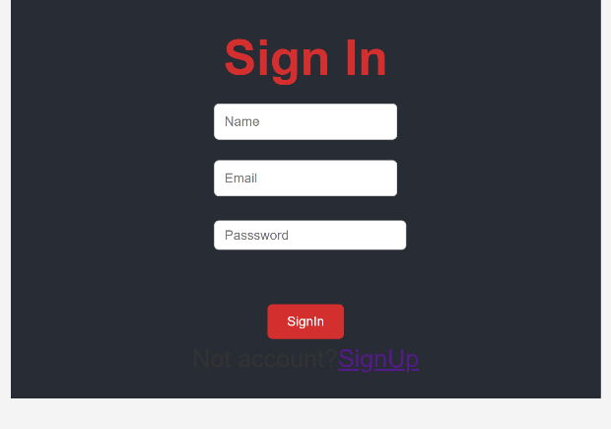

**Figure 11: LogIn Screen**

### *Donate Screen:*

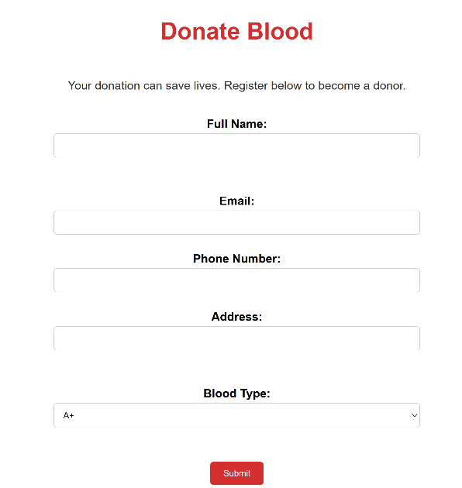To donate we have to give Name, Email, Phone Number, Address and Blood Type.

**Figure 12: Donate Screen**

### *Request Screen:*

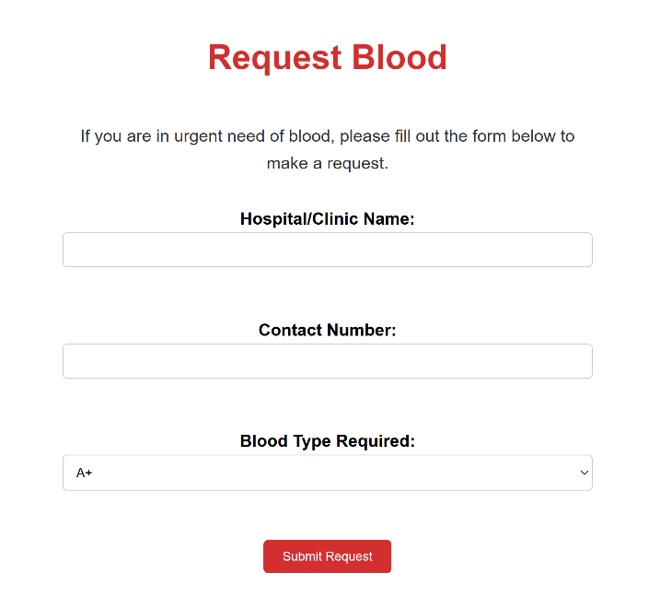Gets the Hospital/Clinic Name, Contact Number and Blood Type which is required.

**Figure 13: Request Screen**

### *SignUp Screen:*

Gets the username, Email and password from the user and create the account of the user.

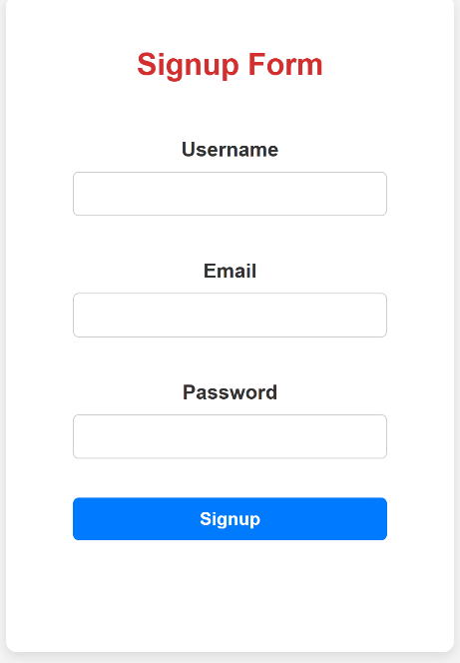

**Figure 14: SignUp Screen**

# 

# Chapter 5

## System Implementation

## Implementation

The system implementation phase of the Web-Based Blood Bank Management System (WB-BBMS) involves turning the system's design into a functional and operational platform. This chapter describes the key components and steps followed during the implementation, including the selection of the technology stack, database implementation, user interface development, integration of various modules, and security considerations.

## Tools and Technologies

In the development of a system like this, tool selection is critical. The tools used in the development are listed below.

* HTML5
* CSS3
* JavaScript
* React JS
* Node JS
* Express JS
* MySQL

## Frontend

For the frontend development of the blood bank management system, we will be using ReactJS, a popular JavaScript library for building user interfaces. ReactJS provides a component-based architecture that facilitates the creation of interactive and dynamic user interfaces. With its virtual DOM and efficient rendering, ReactJS ensures a smooth user experience. The frontend will be responsible for displaying the user interface, handling user interactions, and communicating with the backend API.

## Backend

The backend of the system will be developed using Node.js and Express.js. Node.js is a runtime environment that allows us to build server-side applications using JavaScript. Express.js is a web application framework for Node.js that simplifies the process of building robust and scalable APIs. The backend will handle user authentication, payment processing through the Stripe payment gateway, document application workflows, and interaction with the database.

## Database

The system's database will be managed using MongoDB, a powerful relational database management system. MongoDB will store and manage user data, appointment form, patient details, and other relevant information. Proper database design, including tables, relationships, and indexes, will ensure efficient data storage and retrieval. The integration of frontend, backend, and the database will be achieved through RESTful API endpoints. These APIs will facilitate data exchange between the frontend and backend, enabling seamless user interactions and system functionality.

## Testing and Quality Assurance

During the implementation phase, thorough testing will be conducted to ensure the system's functionality, security, and performance. Different types of testing, including unit testing, integration testing, and end-to-end testing, will be carried out to identify and rectify any bugs or issues. Security testing will focus on validating data encryption, authentication mechanisms, and payment gateway security. Performance testing will gauge the system's responsiveness and stability under various load conditions.

## Deployment and User Training

Once the implementation and testing phases are complete, the system will be deployed to a suitable hosting environment. Continuous integration and deployment (CI/CD) practices may be employed to automate the deployment process. After deployment, user training and support will be provided to ensure that healthcare staff and patients can effectively use the system to schedule their appointment, blood inventory, and manage their interactions.

## Maintenance and Updates

Following the system's deployment, regular maintenance and updates will be carried out to address any emerging issues, introduce new features, and ensure the system's continued reliability and security. The implementation phase is a critical step in turning the conceptual design of the online fee payment and student services system into a functional and accessible reality. It involves the skillful integration of frontend and backend technologies, the establishment of a robust database, and rigorous testing to guarantee a seamless and efficient user experience.

# Chapter 6

## SYSTEM TESTING AND EVALUTION

System testing is a crucial phase in the software development lifecycle, aimed at validating the complete and integrated software product to ensure it meets specified requirements. This phase involves executing the system in a controlled environment to identify any defects or issues before deployment. For the Web-Based Blood Bank Management System (WB-BBMS), system testing will focus on functional, non-functional, and performance aspects of the application to confirm that it operates correctly and efficiently.

## Unit testing

Unit testing is the process of validating individual components of the software to ensure that each unit performs as expected. In the context of the WB-BBMS, unit testing will focus on verifying the functionality of each module separately before they are integrated into the larger system.

### **Unit Testing 1:**

**Module**: User Management Module

**Testing ID: 1**

**Objective:** To Verify that a new user can be registered successfully.

**Test Cases:**

* Check if all required fields (name, contact info, medical history) are captured.
* Verify that valid inputs are accepted and invalid inputs are rejected.
* Confirm that patient data is stored securely in the database.

**Expected Outcome:** User account created successfully.

**Unit Testing 2:**

**Module**: Donor Management module

**Testing ID: 2**

**Objective:** heck that donor eligibility is correctly evaluated based on donation history.

**Test Cases:**

* + Donor details with donation history.
  + Ensure that donor information can be updated correctly.

**Expected Outcome:** Eligibility status (eligible/ineligible).

**Unit Testing 3:**

**Module**: Blood Inventory Management

**Test ID:** 3

**Objective:** To verify the functionality of the blood inventory module for accurate stock management.

**Test Cases:**

* + Confirm that blood donations are properly logged, including blood type and expiry date.
  + Validate real-time inventory tracking for available blood units.
  + Ensure alerts are triggered for low stock or expired units.

**Expected Outcome:** The blood inventory module should accurately track donations, stock levels, and generate alerts for low or expired inventory.

# Chapter 7

## CONCLUSION

To sum up, the creation of the Web-Based Blood Bank Management System (WB-BBMS) is a noteworthy progression in the administration of blood bank activities in medical facilities. Vital blood inventory data becomes more accurate, efficient, and easily accessible with the WB-BBMS, which solves the problems and inefficiencies of manual systems. The project successfully combines essential features including transfusion request processing, blood inventory tracking, and donor management into a single, approachable platform that is accessible from any internet-enabled device.

Unit, integration, and user acceptability testing are among the thorough testing and assessment stages that verify the system satisfies both functional and non-functional criteria. Stakeholder and end-user feedback has been crucial in helping to refine the system and make sure it meets the actual needs of blood banks and healthcare professionals.

The WB-BBMS greatly improves patient safety and care quality by enabling real-time data access, enhancing communication between blood banks and healthcare facilities, and guaranteeing regulatory compliance. In addition to streamlining blood bank operations, this technology enables medical professionals to react quickly to patients' requirements, especially in emergency scenarios where receiving blood in a timely manner may mean the difference between life and death.

## FUTURE WORK

As the Web-Based Blood Bank Management System (WB-BBMS) continues to evolve, several avenues for future work have been identified to enhance its functionality, performance, and impact on healthcare management. A primary focus will be on integrating the WB-BBMS with existing hospital management systems and electronic health records (EHR), facilitating seamless data exchange that allows healthcare providers to access patient and blood inventory information in real-time. This integration will ultimately improve decision-making and patient outcomes.

In addition, developing a mobile application version of the WB-BBMS will enhance accessibility for users on the go, enabling healthcare professionals and donors to manage appointments, receive notifications, and access critical information from their mobile devices. Future work will also involve implementing advanced data analytics features to analyze historical blood donation and transfusion data, providing valuable insights that can help predict future blood demand, optimize inventory levels, and identify trends in donor participation.

Exploring the integration of artificial intelligence (AI) algorithms will further enhance the system's effectiveness by automating donor eligibility assessments, optimizing inventory management, and predicting potential blood shortages. Machine learning models can analyze patterns in donation behavior and patient needs, offering proactive recommendations to improve resource management. To support successful adoption, comprehensive training and ongoing user support will be developed, including training materials, user guides, and support documentation to ensure all stakeholders can effectively utilize the system.

Additionally, enhancing the donor engagement module with features like gamification, rewards for donations, and personalized communication can help boost donor retention and participation rates, fostering a culture of giving. Continuous evaluation of the system's compliance with evolving healthcare regulations and data protection laws will be crucial, leading to the implementation of advanced security measures such as biometric authentication and encryption techniques to safeguard sensitive information.

Establishing a robust feedback mechanism will enable users to report issues, suggest enhancements, and provide insights based on their experiences, helping prioritize future development efforts. Conducting pilot programs and case studies in diverse healthcare settings will offer valuable data on the system's effectiveness and user satisfaction, further informing refinements and validating the benefits of the WB-BBMS. By pursuing these opportunities for future work, the WB-BBMS can significantly optimize blood management processes in healthcare, improve patient care, and foster a more responsive and efficient healthcare system, ensuring its relevance and impact in a rapidly changing landscape.

# References

Elhoseny, M. H. (2021). Advances in Healthcare Informatics: Integrating Blood Bank Modules with Clinical Systems. *Journal of Healthcare Engineering*, 335-350.

Harris, M. &. (2019). Blockchain Technology for Securing Patient and Blood Donor Data in Healthcare Systems. *Journal of Digital Health Security*, 65-77.

Johnson, D. &. (2021). Cloud-Based Systems in Healthcare: A Case Study of CMS and Blood Bank Integration. *Health Information Technology Journal*, 101-115.

Kumar, R. &. (2021). The Role of Integrated Systems in Healthcare: An Analysis of CMS with Blood Bank Integration. *International Journal of Health Technology*, 145-158.

Lee, J. &. (2018). The Importance of Blood Bank Systems in Emergency Healthcare: Challenges and Solutions. *Global Health Technology Journal*, 105-118.

Rahman, H. &. (2021). Real-Time Tracking and Management of Blood Banks in Hospitals: A New Approach. *Biomedical Research Journal*, 147-160.

Sharma, R. &. (2020). Addressing Blood Bank Management Challenges: A Review of Integrated Healthcare Solutions. *International Journal of Blood Research*, 33-46.

Smith, J. &. (2019). mproving Emergency Response Times with Real-Time Healthcare Systems. *Healthcare Innovations Review,*, 75-89.

Zhang, X. W. (2020). Clinical Management Systems: A Comprehensive Review. *Journal of Healthcare Information Systems,* , 213-228.

Zhang, Y. &. (2021). Predictive Analytics in Healthcare: Optimizing Blood Demand and Supply. *Journal of Artificial Intelligence in Medicine*, 231-243.

Zhou, Q. &. (2020). Ensuring Data Security in Integrated Healthcare Systems: The Role of HIPAA and GDPR Compliance. *Journal of Medical Information Security*, 389-400.

# APPENDICES

# Appendix A

USER MANUALS

.

|  |  |
| --- | --- |
|  | To use the system properly user must have active internet connection |
|  | User can use any internet browser on any Device. |
|  | Do not share your banking credentials with anyone you do not trust. |
|  | Any digital payment gateway takes a while to load, so wait patiently. |
|  | Don’t pay your fee using anyone’s device |
|  | Your credentials and data will not be shared or accessed by anyone. |

# Appendix B

SOURCE CODE

## Main frontend code:

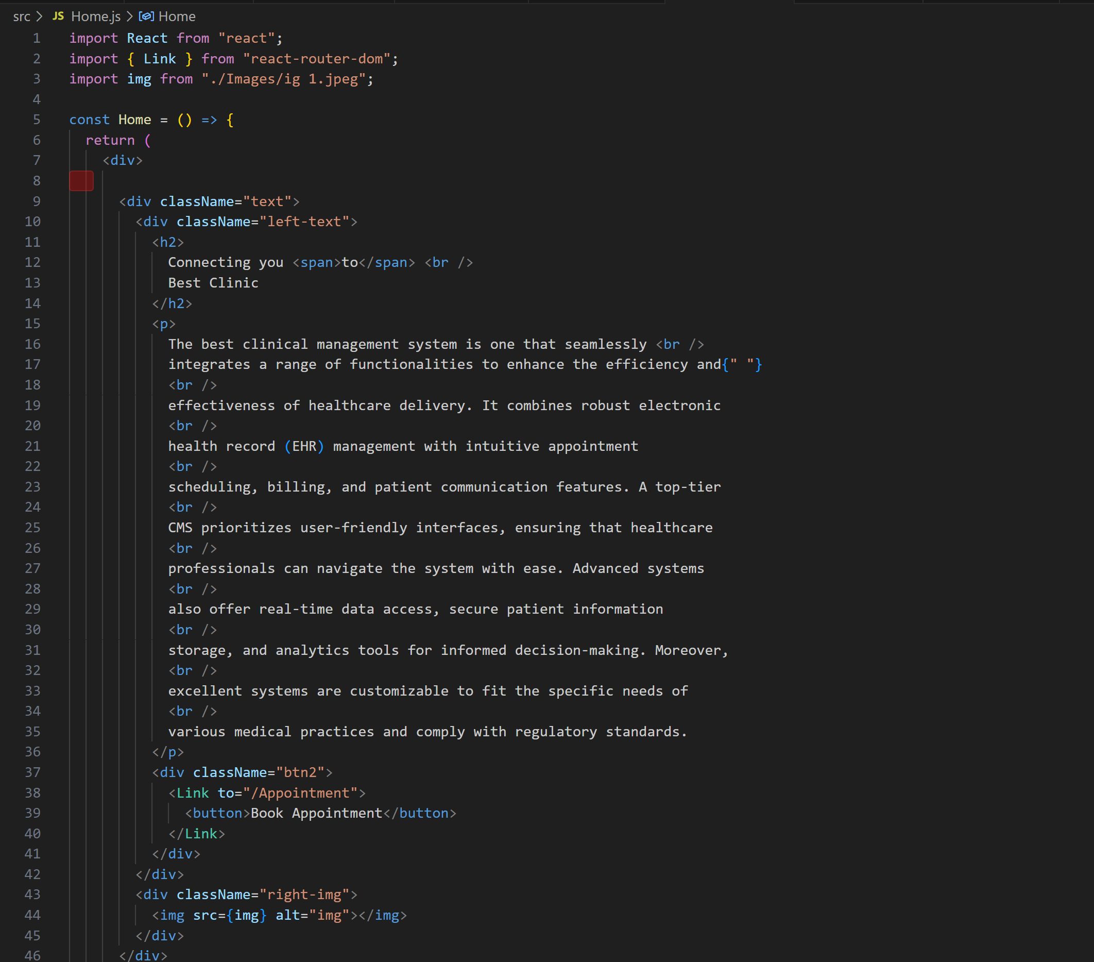It does not contain all the source code but just a sample code

## Main Backend Code: